[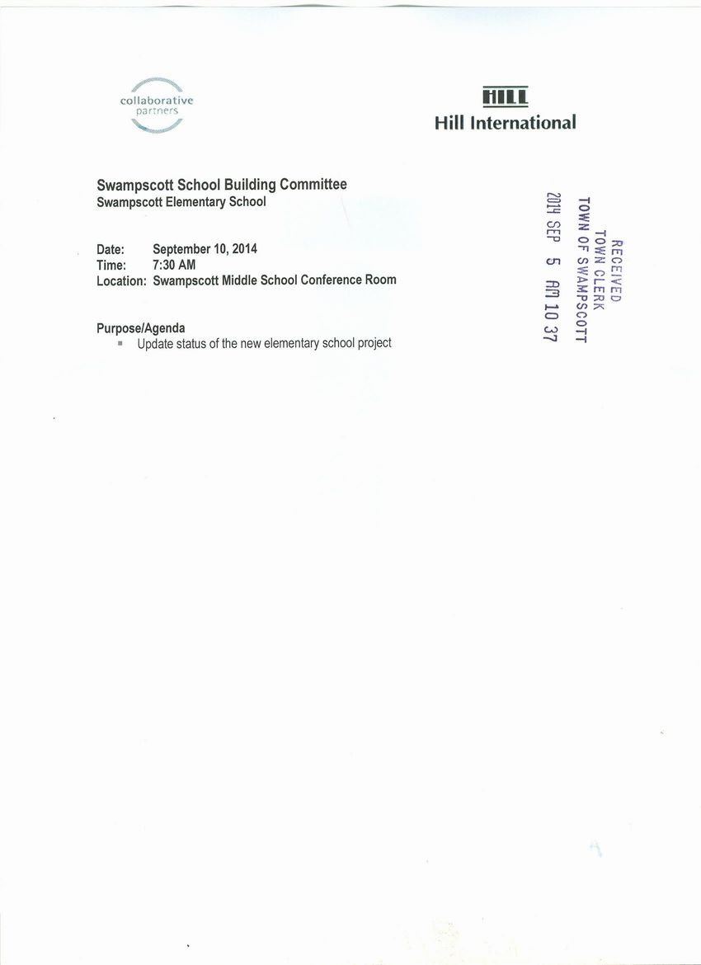](http://www.town.swampscott.ma.us/Public_Documents/SwampscottMA_Calendar/S04AC1DB3-04AC30A3.0/School%20Building%20Committee%20Sept.%2010th%20notice%20001.jpg)